 | 12.1.41 Editors - Geometry Nodes Editor - Header - Add Menu - Utilities - Math
Table of content
Detailed table of content 1
Add menu - Utilities - Math 5
Boolean Math 5
Clamp 6
Compare 7
Float Curve 8
Float to Integer 9
Hash Value 10
Map Range 11
Math 12
Mix 16

Detailed table of content
Detailed table of content
Detailed table of content 1
Add menu - Utilities - Math 5
Boolean Math 5
Inputs 5
Boolean 5
Properties 5
Operation 5
And 5
Or 5
Not 5
Not And (NAND) 5
Nor (NOR) 5
Equal (XNOR) 5
Not Equal (XOR) 6
Imply (IMPLY) 6
Subtract (NIMPLY) 6
Output 6
Boolean 6
Clamp 6
Inputs 6
Value 6
Min 6
Max 6
Properties 6
Clamp Type 6
Min Max 6
Range 6
Outputs 6
Result 6
Compare 7
Inputs 7
A, B 7
Properties 7
Input Type 7
Operation 7
A is less than B 7
A is lesser than or equal B 7
A is greater than B 7
A is greater than or equal B 7
A is equal B 7
A is not equal B 7
Output 7
Result 7
Float Curve 8
Inputs 8
Factor 8
Attribute 8
Properties 8
Curve Field 8
Channel buttons 8
Navigation elements 8
Zoom in and out 8
Use Clipping 8
Tools 8
Reset View 8
Extend horizontal 8
Extend extrapolated 8
Reset Curve 9
Curve edit field 9
Selecting Points 9
Adding Points 9
Curve point settings 9
Vector Handle 9
Auto Handle 9
Auto Clamped Handle 9
Output 9
Value 9
Float to Integer 9
Inputs 10
Float 10
Properties 10
Rounding Mode 10
Outputs 10
Integer 10
Hash Value 10
Input 10
Value 10
Seed 10
Properties 10
Data Type 10
Output 10
Hash 10
Map Range 11
Inputs 11
Value 11
From Min 11
From Max 11
To Min 11
To Max 11
Properties 11
Data Type 11
Interpolation Type 11
Clamp 11
Outputs 11
Value 11
Math 12
Inputs 12
Value 12
Addend 12
Base 12
Exponent 12
Epsilon 12
Distance 12
Min 12
Max 12
Increment 12
Scale 12
Degrees 12
Radians 12
Properties 13
Operation 13
Functions 13
Add 13
Subtract 13
Multiply 13
Divide 13
Multiply Add 13
Power 13
Logarithm 13
Square Root 13
Inverse Square Root 13
Absolute 13
Exponent 13
Comparison 13
Minimum 13
Maximum 13
Less Than 14
Greater Than 14
Sign 14
Compare 14
Smooth Minimum 14
Smooth Maximum 14
Rounding 14
Round 14
Floor 14
Ceil 14
Truncate 14
Fraction 14
Modulo 14
Wrap 14
Snap 14
Ping-pong 14
Trigonometric 15
Sine 15
Cosine 15
Tangent 15
Arcsine 15
Arccosine 15
Arctangent 15
Arctan2 15
Hyperbolic Sine 15
Hyperbolic Cosine 15
Hyperbolic Tangent 15
Conversion 15
To Radians 15
To Degrees 15
Clamp 15
Outputs 15
Value 15
Use Clipping 16
Delete Points 16
Curve window 16
X / Y values 16
Mix 16
Input 16
Float 16
Factor 16
A 16
B 16
Properties 16
Clamp Factor 16
Output 17
Result 17

Add menu - Utilities - Math
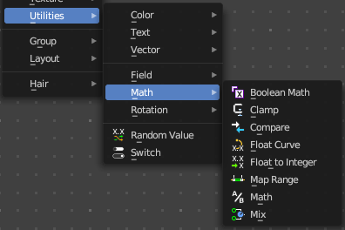
Utility nodes are mainly for mathematical operations.

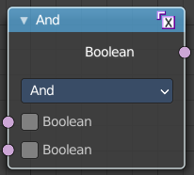
Boolean Math
The Boolean Math node performs a basic logical operation between its inputs.

Inputs

Boolean
Two standard Boolean inputs.

Properties

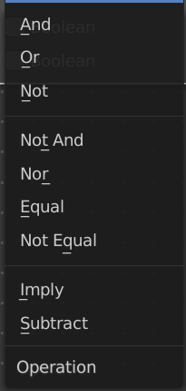
Operation

And
True if both inputs are true.

Or
True if either or both inputs are true.

Not
True if both inputs are false.

Not And (NAND)
True when at least one input is false.

Nor (NOR)
True when both inputs are false.

Equal (XNOR)
True when both inputs are equal.

Not Equal (XOR)
True when both inputs are different.

Imply (IMPLY)
True unless the first input is true and the second is false.

Subtract (NIMPLY)
True when the first input is true and the second is false.

Output

Boolean
Standard Boolean output.

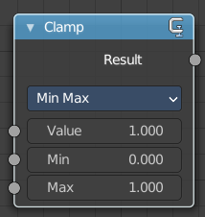
Clamp
Clamps a value between a minimum and a maximum.

Inputs

Value
The input value to be clamped.

Min
The minimum value.

Max
The maximum value.

Properties

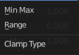
Clamp Type

Min Max
Clamp values using Min and Max values.

Range
Clamp values between Min and Max range.

Outputs

Result
The input value after clamping.

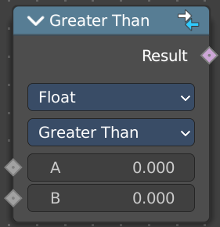
Compare
The Compare node takes two inputs and does a math comparison between them.

Inputs

A, B
Standard float value input.

Properties

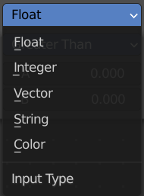
Input Type
What kind of data to compare.

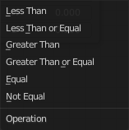
Operation

A is less than B
True if A is smaller than B.

A is lesser than or equal B
True if A is smaller or equal than B.

A is greater than B
True if A is bigger than B.

A is greater than or equal B
True if A is bigger or equal than B.

A is equal B
True if A and B are the same.

A is not equal B
True if A and B are different.

Output

Result
Standard Boolean output.

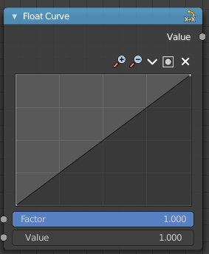
Float Curve
The Float Curve node maps an input float to a curve and outputs a float value. This curve can then be used for profiles for example.

Inputs

Factor
How strong the input influences the output value.

Attribute
The input value.

Properties

Curve Field

Channel buttons
Clicking on one of the channels displays the curve for each.
C (Combined RGB), R (Red), G (Green), B (Blue).


Navigation elements
They are described from left to right.

Zoom in and out
The two buttons with the magnifying glass at it zooms in and out in the curve window.


Use Clipping
Clipping options. Set up clipping for the stroke.

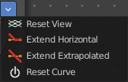
Tools
Tools is a menu where you can find some curve related tools.

Reset View
Resets the curve windows zoom.

Extend horizontal
Extends the curve before the first curve point and behind the last curve point horizontally.

Extend extrapolated
Extends the curve before the first curve point and behind the last curve point extrapolated.

Reset Curve
Resets the curve to the initial shape.

Curve edit field
Create and tweak a Bezier curve that varies the input levels (X axis) to produce an output level (Y axis).

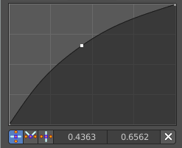
Selecting Points
You can select curve points. This reveals two edit boxes for the x and y coordinate of this point.
Selected points can be moved around. Left click at them, hold the mouse button down and move them to a new location.

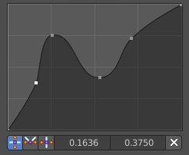
Adding Points
You can add new curve points by simply left clicking at the curve. Move the mouse to position them where you need it.

Curve point settings
When you have a point selected then you will reveal further settings at the bottom.

Vector Handle
Set handle type to Vector.

Auto Handle
Set handle type to Auto.

Auto Clamped Handle
Set handle type to Auto Clamped.

Output

Value
The output value.

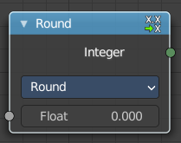
Float to Integer
Converts a floating point value into an integer value.

Inputs

Float
The input float value.

Properties

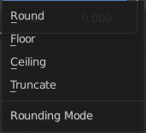
Rounding Mode
How the float value should be converted.

Outputs

Integer
The output integer value.

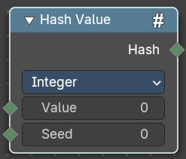
Hash Value
The hash value converts a value input into a hashed value.
Note that Hashes cannot be relied upon to be used as unique identifiers because they are not guaranteed to be unique. It can be used to generate somewhat stable randomness especially in cases where White Noise does not offer enough flexibility.

Input

Value
The input value.

Seed
A seed to randomize the value.

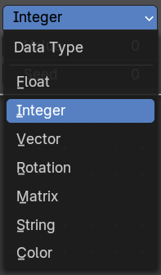
Properties

Data Type
What data type to create.

Output

Hash
The hash value output.

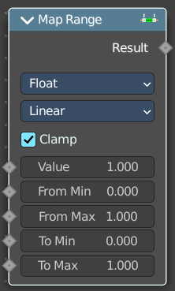
Map Range
This node converts (maps) an input value range into a destination range. By default, values outside the specified input range will be proportionally mapped as well. This node is similar to Map Value node but provides a more intuitive way to specify the desired output range.

Inputs

Value
Standard value input.

From Min
Start of the input value range.

From Max
End of the input value range.

To Min
Startof the destination range.

To Max
End of the destination range.

Properties

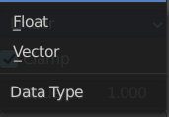
Data Type
The data type to calculate.

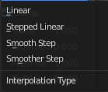
Interpolation Type
how to interpolate the values between min and max.

Clamp
Clamps values to Min/Max of the destination range.

Outputs

Value
Standard value output.

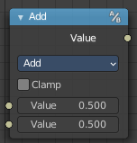
Math
The Math Node performs math operations.

Inputs
The inputs of the node are dynamic. Some inputs are only available with certain operations. For example, the Addend input is only available in the Multiply Add operator.

Value
Input Value. Trigonometric functions read this value as radians.

Addend
Input Addend.

Base
Input Base.

Exponent
Input Exponent.

Epsilon
Input Epsilon.

Distance
Input Distance.

Min
Input Minimum.

Max
Input Maximum.

Increment
Input Increment.

Scale
Input Scale.

Degrees
Input Degrees.

Radians
Input Radians.

Properties

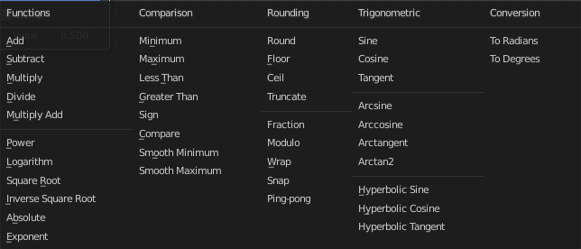
Operation
The mathematical operator to be applied to the input values:

Functions

Add
The sum of the two values.

Subtract
The difference between the two values.

Multiply
The product of the two values.

Divide
The division of the first value by the second value.

Multiply Add
The sum of the product of the two values with Addend.

Power
The Base raised to the power of Exponent.

Logarithm
The log of the value with a Base as its base.

Square Root
The square root of the value.

Inverse Square Root
One divided by the square root of the value.

Absolute
The input value is read with without regard to its sign. This turns negative values into positive values.

Exponent
Raises Euler’s number to the power of the value.

Comparison

Minimum
Outputs the smallest of the input values.

Maximum
Outputs the largest of two input values.

Less Than
Outputs 1.0 if the first value is smaller than the second value. Otherwise the output is 0.0.

Greater Than
Outputs 1.0 if the first value is larger than the second value. Otherwise the output is 0.0.

Sign
Extracts the sign of the input value. All positive numbers will output 1.0. All negative numbers will output -1.0. And 0.0 will output 0.0.

Compare
Outputs 1.0 if the difference between the two input values is less than or equal to Epsilon.

Smooth Minimum
Smooth Minimum.

Smooth Maximum
Smooth Maximum.

Rounding

Round
Round the input value to the nearest integer.

Floor
Rounds the input value down to the nearest integer.

Ceil
Rounds the input value up to the nearest integer.

Truncate
Outputs the integer part of the value.

Fraction
Fraction.

Modulo
Outputs the remainder once the first value is divided by the second value.

Wrap
Outputs a value between Min and Max based on the absolute difference between the input value and the nearest integer multiple of Max less than the value.

Snap
Round the input value to down to the nearest integer multiple of Increment.

Ping-pong
The output value is moved between 0.0 and the Scale based on the input value.

Trigonometric

Sine
The Sine of the input value.

Cosine
The Cosine of the input value.

Tangent
The Tangent of the input value.

Arcsine
The Arcsine of the input value.

Arccosine
The Arccosine of the input value.

Arctangent
The Arctangent of the input value.

Arctan2
Outputs the Inverse Tangent of the first value divided by the second value measured in radians.

Hyperbolic Sine
The Hyperbolic Sine of the input value.

Hyperbolic Cosine
The Hyperbolic Cosine of the input value.

Hyperbolic Tangent
The Hyperbolic Tangent of the input value.

Conversion

To Radians
Converts the input from degrees to radians.

To Degrees
Converts the input from radians to degrees.

Clamp
Limits the output to the range (0.0 to 1.0). See Clamp.

Outputs

Value
Numerical value output.


Use Clipping
Clipping options. Set up clipping for the stroke.

Delete Points
Deletes selected curve point.

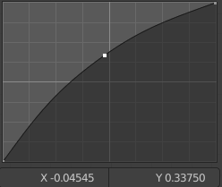
Curve window
Tweak and adjust the falloff curve by clicking at a curve point and dragging it around.
Double click adds a new point.
Holding down ctrl activates temporary snapping.
Holding down shift enables slower movement, which allows more accurate setting.

X / Y values
The x and y value of the currently selected point.

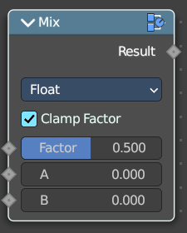
Mix
Allows to mix values and vectors in various ways. The node has three different modes. Float, Vector and Color. This node covers the Float mode

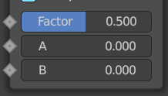
Input

Float

Factor
The mix factor.

A
Float value A input.

B
Float value B input.

Properties

Clamp Factor
Clamp the factor to 0-1 range.

Output

Result
The output value or vector.

